CHAPTER 0

**PROLOGUE**

It was the year ALR-6126. The Great Authority Hall in Astronova buzzed with tension as the authority and their committee assembled, marking the tenth anniversary of Velnut’s prison break. The air was thick with concern over the possibility of Velnut's return.

Astrach of Galaxar: "Do you really think we can trust that old geezer? We should be prepared for an attack at any moment."

Astrach of Orionis: "I have complete faith in my old mentor! We have ample time before any potential threat arises."

Astrach of Cosmoria: "I agree with the Astrach of Galaxar. Remaining vigilant is our best defense."

Astrach of Novarion: "I trust the Time Legendary. Even with increased power, we cannot avoid the impending war. The Key of Cosmos is our only hope."

Astrach of Luminae: "So, are you suggesting we sit idly by until the Key of Cosmos awakens? Should we simply wait with folded hands?"

Astrach of Novarion: "We must first focus on eliminating the corruption that has spread throughout our dominion. Only then can we hope to prepare adequately for the impending war."

(Arguments ensue among the Astrachs)

Supreme Astrach (of Staranthea): "Silence!" (he shouted) "Our primary goal is to eradicate the corruption that plagues our dominion. Only then can we nurture the strength and capabilities needed to face the looming threat of war. According to the Time Legendary, the war is roughly 8-10 years away. Until then, we must aid in the search for the Key of Cosmos, our only beacon of hope. With that, I adjourn this meeting."

**NOTE:**

Zorgonax is a cluster in space comprising many galaxies, 9 of which are inhabited: **Staranthea, Orionis, Cosmoria, Nebulon, Galaxar, Novarion, Luminae, Celestius, and Andromir**. Together it is called as **Zorgonax Dominion**.

**Astarch:** Ruler/leader of a galaxy, with high ranking.

Andromir has no people living on it and also has no Astrach, but it serves as the seat of the main authority, established to maintain peace and harmony throughout the dominion. Each inhabited galaxy (except Andromir) is governed by an **Astarch**, and all 8 Astarch collectively form the main authority that governs the dominion. The most powerful and elected among them is the Supreme Astarch, who leads the main authority. In this era, Ardorious holds the title of Supreme Astarch.

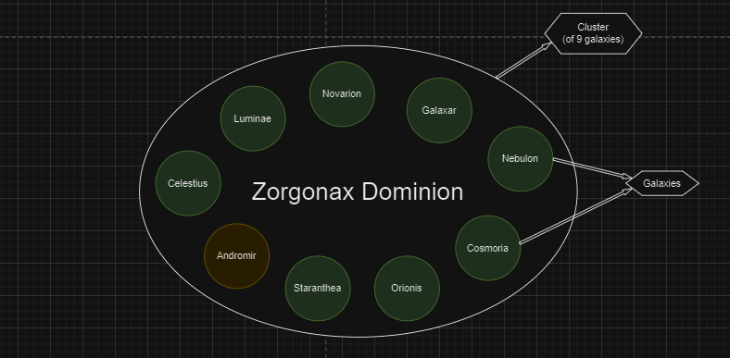

* * *

Astarch of Orionis, Aeon Falk returned to Orionis and met the old man, the Time Legendary, Hans Falk.

Aeon: “What are your opinions? How can we best prepare to be effective allies in the upcoming war?”

Hans: “To be honest, it doesn’t matter what you do. But I am a quite excited, this is the year, a significant stride will be made, to defeat my old friend. And also, to have my revenge. (his eyes gleaming with a fiery resolve)”

Aeon: “Ah, you and your old age fantasies.”

* * *

“Wake up, son!” Viden's voice echoed through the halls as she rushed towards Yash’s room. “Today is an important day. We need to leave for school on time.”

Yash tumbled out of bed with a resounding thud. Panic in his voice, he replied, “Oh no, am I late?” “I’m coming, Mom!” he shouted, darting out of his room to get ready.

“Don’t rush too much, honey,” Shivon advised Viden. “We still have time. And Yash, take your time getting ready. We won’t be leaving just yet.”

“I just can’t believe it, Yash is 10 now and ready to go to school. It feels like just yesterday when we were in school. In such a short time, we have a son who’s already 10,” Viden remarked to Shivon, a hint of nostalgia in her voice.

“Yeah, and now he’s ready to embark on his own journey in school. Time flies by so quickly,” Shivon agreed, a wistful smile playing on his lips.

As Yash emerged from his bath, Viden called out to him, “Come here, kiddo, give your mom a big hug.” “I’ll miss you, son,” she added softly.

“I’ll miss you too, Mom and Dad,” Yash replied, his voice tinged with emotion.

“No need for tears, son. You’re about to start the adventure of a lifetime—making friends, learning, playing, and yes, even facing a few challenges along the way. And who knows, you might even meet some girls your age,” Shivon teased, trying to lighten the mood.

“Alright, let’s head to school now!” Viden exclaimed, a sense of excitement in her voice as they all made their way out the door.

Yash and his family climbed into their lightbuzzer, ready to journey to the School of Powers in the Orionis galaxy.

**Lightbuzzer:** A sleek, compact space-vehicle, could travel across planets and galaxies with ease. Most families owned one, using it to traverse the vast distances between the stars.

* * *

Yash and his family arrived on SP1, a planet in the Orionis Galaxy specifically designed for the School Phase 1. This is the place where children from all galaxies across the Zorgonax Dominion take their first steps towards learning and mastering their powers. SP1 is a unique planet with a single city dedicated entirely to the education and growth of Phase 1 students.

At the heart of this city lies the expansive school campus, a beacon of knowledge and power. The campus is vast, with meticulously maintained grounds and a variety of buildings that serve different purposes. In the center stands the grand library, a towering structure filled with ancient texts, modern literature, and every resource a student might need. Surrounding the library are huge halls used for assemblies, orientations, and other large gatherings. These halls are architectural marvels, designed to inspire awe and respect in every student.

The campus also houses numerous buildings for classrooms, each equipped with state-of-the-art technology and facilities to enhance learning. There are staff rooms for the teachers and administrative offices, ensuring the smooth operation of the school. The canteens, strategically placed around the campus, offer a wide variety of nutritious meals to keep the students energized and focused.

Encircling this magnificent campus are the hostels where students reside. Each hostel is a blend of comfort and functionality, providing students with a homely atmosphere while ensuring they have everything they need to succeed. The hostels are grouped into clusters, each cluster having its own dining mess where students gather to eat and socialize.

Beyond the hostels, the city extends into gardens, parks, and recreational areas. These green spaces offer students a chance to relax, meditate, and connect with nature amidst their rigorous academic schedule. Scattered throughout the city are various shops and hotels. The shops provide essentials, from books and stationery to clothing and personal items, while the hotels accommodate visiting families and guests.

Despite the bustling life within the city, the land surrounding it is starkly different. All around the city, the terrain turns into an infertile and uninhabited expanse. This barren land, while devoid of life, serves a crucial purpose. Students often visit these outskirts to practice and train their powers, engaging in friendly fights and honing their skills in a safe, controlled environment. This land provides a stark contrast to the city, emphasizing the importance of balance between learning and practice, theory and application.

SP1 is a microcosm of the Zorgonax Dominion's dedication to education and empowerment. It is a place where young minds are molded, friendships are forged, and the future leaders of the galaxies are nurtured. For Yash and many other students, this planet is not just a school; it is the beginning of a lifelong journey of discovery and growth.

**Structure of Planet SP1**

**Location:** Orionis Galaxy

**City:** Comprises students' hostels and facilities, with the school campus at the center of the city

**Inhabitant Land:** Surrounding the city, with no life

* * *

All the parents and students had gathered near the great hall on the campus. Parents were preparing to say their final goodbyes, while the children were filled with excitement and anticipation, eager to embark on their school journey, learn new things, and make friends.

Shivon and Viden spotted some familiar faces among the crowd. They recognized their old friends who were now there to send off their own children. “Hey, Naren! Long time no see! How’s everything going?” Shivon called out, waving at his old friend.

“Hey, Shivon and Viden! Hi there!” Naren responded with a smile, walking over to them. “I didn’t expect to run into you here. Oh, is this your little avenger? What’s your name, young man?”

“Hello, uncle. I’m Yash. Nice to meet you,” Yash greeted Naren and his family politely.

“Nice to meet you, Yash. This is my boy, Ram,” Naren introduced his son.

“Hello, Yash. I’m Ram,” Ram said, smiling at Yash.

A loud announcement echoed through the area, drawing everyone’s attention. “Hello everyone! We hope the parents have had a chance to say their farewells. Students, please proceed to the great hall for the orientation. At the entrance, you can submit your luggage, which will be transferred to your respective hostels. Once inside, find a seat. The orientation will begin shortly. Parents, it’s time to leave your children in our care. You will meet them again during the scheduled parents’ visit. Until then, goodbye.”

“It looks like it’s time for you kids to go in, and for us to head out,” Viden said, giving Yash a reassuring pat on the shoulder.

“Yes, goodbye, son. We’ll see you soon,” Shivon added, hugging Yash tightly.

“Bye, Mom and Dad. I’ll miss you,” Yash said, his voice tinged with emotion. Ram echoed his sentiments as they both waved goodbye to their parents and hurried toward the great hall, ready to begin their new journey.

As Yash and Ram joined the stream of students entering the hall, they felt a mix of nervousness and excitement. It was the start of a new chapter, filled with endless possibilities and adventures waiting to unfold.